To work on this script, we need to import the Excel File as shown in the screenshot below:

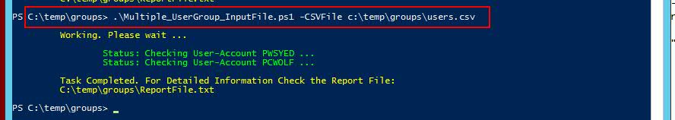

Navigate to the path on which the Script file is saved, and also import the file from the same location.  
The output file , will be saved on the same location, and it is named “ Reportfile.txt “.